**Luna’s List**

**Software Solution Ltd. (SSL) – Formerly Team J**

[**https://github.com/Reiterpallasch/4882-Capstone**](https://github.com/Reiterpallasch/4882-Capstone)

**Version 0**

**Sprint 0 Report**

**Project Summary:**

Luna’s List is intended to be a platform in which canine lovers may discover and share locations that are dog friendly. In doing so, the platform will allow for the rules of the location to be well laid out, such as if aggressive dogs are allowed, or if a leash need be employed. The platform will also allow for those of the canine affinity to come together in varying ways, whether it be casual or formal. To sum it up simply, one may view it as an initially low-level canine lover’s social network with great potential for expansion. Initially it is to be web based, however, mobile expansion is within its grasp.

**Problem Statement:**

Provided by the customer:

Dogs have been interwoven into our lives at a scale never seen before. They have moved outside of the perimeter of our homes and yards and into our roads, stores and entertainment areas.

More and more questions have flooded businesses, parks, and buildings on when, where and how can I bring my dog?

Lunas List will help answer these questions and more by providing a platform that provides communities with Dog friendly spaces.  It will also bring Dog Owners together in different ways.

**Team Profile:**

Wesley Jones:

Strengths – Organization, Python, Java, MYSQL, Data Management

Interests – High End Hardware, Programming, New Technology, Biomedical Engineering

Career Goals – Testing, Programming, Design and Analysis

Role – Scrum Master, Developer

Larz Leonard:

Strengths – Java, Python, HTML, Ruby

Interests – Programming, AI

Career Goals – Programming, Game Development

Role – Developer

Thi Phan:

Strengths - Python, Java, Swift, Ruby on Rails

Vinh Tran:

Strengths - Java, C/C++, minor amount in SQL

Noah Hanks:

Strengths - Python, C++, SQL, Ruby on Rails

**Development Process:**

Thus far, the Agile Scrum method is being learned and in its infancy of implementation. The process has begun with a Sprint 0 in order to both learn the basics of the Agile Scrum method. Sprint planning took place to understand what was going to be the primary goal, as well as meeting time and places, and other methods of contact. Standing as the team does now, the decision for Scrum meetings to occur twice a week is in place. Sprint planning is not as often following a timing of closer to two weeks apart. Thus far, Sprint planning has consisted of determining what is to be accomplished during the sprint, and scrum meetings used to discuss where the team was in finishing the tasks as well as discuss concerns.

In testing the JIRA platform, items have been selected based on the needs of the team at the time. This is likely to change as the project is ramping up, and the sandbox phase for testing is coming to a conclusion. Item priority was decided in a logical manner similar to what one would expect a flowchart to do, understanding that to move on, an initial item must first be completed.

Communication consists of Scrum meetings, Slack channels, Email, and Github. These platforms were felt best to effectively and consistently maintain communication flowing in a manner that all team members are up to date.

**Glossary of Terms:**

Mobile – Platform description for phones and tablets

**Requirements, Analysis, Design, Results:**

This section is still largely under construction as the project begins to move underway.

**Functional Requirements:** What the project should do

Essentially the project is going to allow dog owners to connect via finding dog friendly places. The scope of methods for what will be included aside from being able to list dog friendly locations is still being worked out.

**Non Functional Requirement / Specification:**

Currently, the plan is for the platform to be based on ruby on rails given the team’s recent experience in its use. As for source code organization, Github is to be used to have a root folder. Ultimately, the organization will depend largely on which platform is used to create the project.

**Backlog:**

|  |  |  |
| --- | --- | --- |
| **Issue #** | **Title** | **Priority** |
| 18 | Create Requirements | Medium |
| 20 | Sketching prototype for iOS app | Low |
| 21 | Test story issue | High |

**Burn Down Chart:**

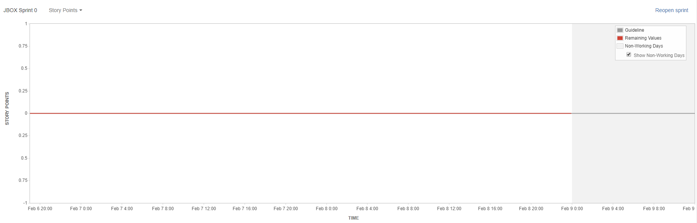

We believe the line to be flat due to story points not being set.

**Risk Tracking Table:**

Not yet in existence, however as Sprint 1 initiates, a log will be kept of each open issue with the priorities listed.

**Summary of Retrospectives:**

Table of Retrospectives

|  |  |  |  |
| --- | --- | --- | --- |
| Sprint # | What did we do well and should carry on doing? | What did we do that we should be avoiding in future? | What were the surprises (unusual items) during the sprint? |
| Sprint 0 | We should carry on with picking the relevant topics to be spoken about during each meeting. | Staying on track during discussion and not diverging should be practiced given a couple of times that it has happened, however, even in this, the talking points of the meeting were still met, thus care needs to be taken. | No real surprises as of yet. |

**SCRUM Sample:**

**1/28/2019**

Each team member needs to read and understand the uploaded projects and begin to formulate their thoughts on performing the project so that one may be decided upon.

Choose a primary project of interest, and everyone’s thoughts will be discussed.

Begin to play with the JIRA sandbox and garner an understanding of the system, as it is going to play a major part in the project development.

Run through the JIRA tutorial such that everyone will understand how to use the system and if questions are had, they may be brought up and discussed.

**Conclusions:**

Current sprint results indicate that each team member is doing their part to learn the JIRA system such that future implementation will not hinder the project completion or recording. Primary goals of determining a project and contacting the owner for an initial introduction have been completed. This indicates that planning and estimation are well under way to having a strong footing.

It is the case, however, that issues need to be tackled in perhaps a slightly faster manner, not allowing any one task to potentially hit a deadline and have little to no work put into it.

**Appendix:**

**SCRUM meeting:**

**1:**

Ruby or Javascript potential. We will use something everyone is comfortable with.

We should focus on the process and always note what works versus what didn’t. Obviously project completion with a working product is important, but the process is just as important to learn.

Ensure everyone understands the uploaded documents for reports.

Decide on the team name to be unique.

**2:**

Look at the uploaded projects so that we can begin determining what everyone wants to do. Be sure to pick a primary and backup projects that are liked.

Begin learning JIRA and play with the sandbox. Be sure to sign in to JIRA and comment on the checklist for participation. Go through the JIRA tutorial.

Consider what each role is going to require.

**3:**

Make note that Sprint 0 will be coming to an end soon, so be sure to have the JIRA tutorial completed, and play around in the sandbox.

Establish who is responsible for what parts.

Decide on a project by the end of the meeting.

**Customer Client Discussions:**

**Email 1:**

Mr. Rivera,

We will be the team working on your project "Luna's List". We have a few questions we would like to ask regarding the project.

* What is your preferred way of communicating (email, phone, skype, etc.)?
* Is the primary vision for the project mobile or web based? (As a group we have very limited mobile development experience so web-based would be preferred)
* Do you have any specific vision for the UI design of the site or will that be left to us to decide?
* Do you have a full problem statement already created or will that need to be generated

Thanks in advance!

**Email 2:**

Noah,

Thanks for reaching out. I am excited about working with you and the team!

My preferred way of communication is all 3.  First email for anything quick. Then skype in order to communicate effectively. Finally for anything urgent phone would be best.

We could absolutely do web based and move to mobile after the MVP.

I will leave it to the group on UI vision.  Some elements that are important will be ease of use and interesting as well as organized and visually appealing.

The full problem statement is here:

Dogs have been interwoven into our lives at a scale never seen before. They have moved outside of the perimeter of our homes and yards and into our roads, stores and entertainment areas.

More and more questions have flooded businesses, parks, and buildings on when, where and how can I bring my dog?

Lunas List will help answer these questions and more by providing a platform that provides communities with Dog friendly spaces.  It will also bring Dog Owners together in different ways.

Noah can I ask for a quick bio or resume of the group who is working on this project. And let me know if you have any questions. Also, is there milestone dates that are already established?

My number is 281.513.1354.

Thank you in advance,

Victor M. Rivera

**Email 3:**

Mr. Rivera,

Thanks for your response. As requested, here is a quick bio of the team members:

Thi Phan: Python, Java, Swift, Ruby on Rails

Wesley Jones: Python, Java, Ruby on Rails

Larz Leonard: Java, Python, Ruby on Rails

Vinh Tran: Java, C/C++, SQL

Noah Hanks: Python, C++, SQL, Ruby on Rails

Since most of us have experience with Ruby on Rails, it would probably be the best platform for us to base the project on. In regards to your question about milestones, the dates are not established yet but there will be a total of 4 sprints. If you have any more questions please feel free to ask.

Noah Hanks